Do the following steps and compile a written report on how you did that and the outcomes

List (or capture) the docker management commands.

docker create

docker start

docker stop

docker restart

docker pause

docker unpause

docker rename

docker rm

docker ps

docker stats

docker top

docker logs

List (or capture) the commands that belong to docker image and what they do.

|  |  |  |
| --- | --- | --- |
| docker pull | This command is used to pull an image from a Docker registry. | docker pull ubuntu:latest |
| docker build | This command is used to build a new Docker image from a Dockerfile. | docker build -t my-image. |
| docker push | This command is used to push a Docker image to a Docker registry. | docker push my-image |
| docker tag | This command is used to tag a Docker image with a new name or version. | docker tag my-image my-image:latest |
| docker rmi | This command is used to remove one or more Docker images. | docker rmi my-image |
| docker images | This command is used to list the Docker images available on the host. | docker images |
| docker history | This command is used to display the history of a Docker image. | docker history my-image |
| docker save | This command is used to save a Docker image to a tar archive. | docker save my-image -o my-image.tar |
| docker load | This command is used to load a Docker image from a tar archive. | docker load -i my-image.tar |

How would you get help on docker image ls command?

Docker help image ls

Give two examples of commands that can be run in two ways in docker?

docker ps -a or docker container ls -a: Lists all containers, including stopped ones.

docker run -it [image_name] or docker run --interactive --tty [image_name]: Runs a container in interactive mode.

5. List the docker images you have on your machine? Run the command and capture the

results.

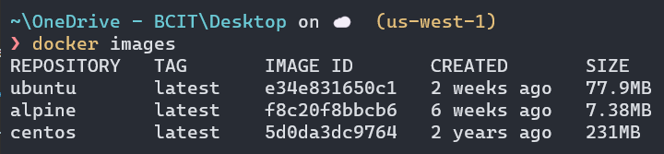

6. List all the containers on your machine. Run the command and capture the results.

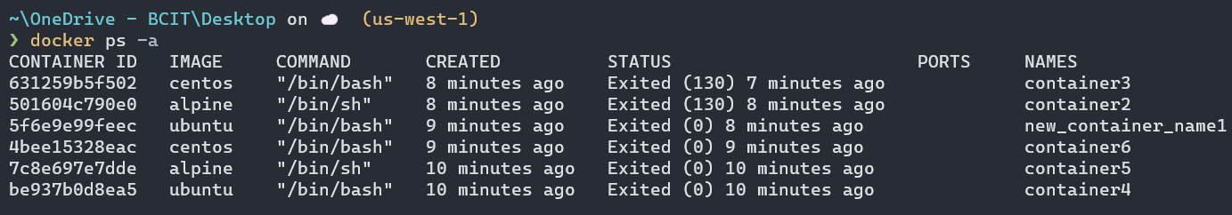

7. Run 3 containers on your machine with 3 different operating systems in detached mode

and in interactive mode.

8. Run any Linux command on a container running in the background.

9. Rename one of the containers to another name.

10. Clean up all containers on your system?

